Loose Coupling / Decoupled

📌 Definition:
# Source: AI Source: Provided by: [Data Path: Persons Table -> ID Column: 1, Name_En Column: Motasem Essam] -> From: [Chatgpt (GPT‑5 Mini)] on [12/9/2025]
Loose Coupling (also called Decoupled) occurs when classes or modules have minimal dependencies on each other, so changes in one module have little or no effect on others.

🧠 Simple idea:
# Source: AI Source: Provided by: [Data Path: Persons Table -> ID Column: 1, Name_En Column: Motasem Essam] -> From: [Chatgpt (GPT‑5 Mini)] on [12/9/2025]
“Modules work independently” 🔗✅

🔍 Key characteristics:
# Source: AI Source: Provided by: [Data Path: Persons Table -> ID Column: 1, Name_En Column: Motasem Essam] -> From: [Chatgpt (GPT‑5 Mini)] on [12/9/2025]
- Classes interact through interfaces or abstractions rather than concrete implementations
- ✅ Easier to maintain and test
- ✅ Improves reusability
- ✅ Reduces the chance of errors when changing code

📊 Example:
# Source: AI Source: Provided by: [Data Path: Persons Table -> ID Column: 1, Name_En Column: Motasem Essam] -> From: [Chatgpt (GPT‑5 Mini)] on [12/9/2025]
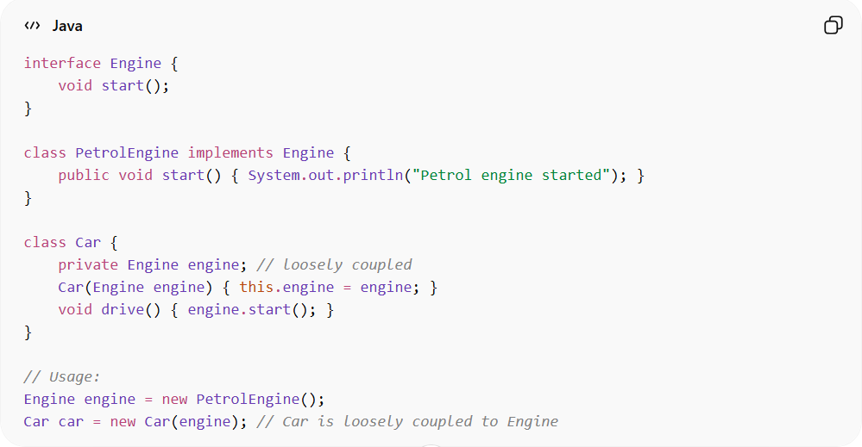
interface Engine {
void start();
}

class PetrolEngine implements Engine {
public void start() { System.out.println("Petrol engine started"); }
}

class Car {
private Engine engine; // loosely coupled
Car(Engine engine) { this.engine = engine; }
void drive() { engine.start(); }
}

// Usage:
Engine engine = new PetrolEngine();
Car car = new Car(engine); // Car is loosely coupled to Engine
- ✅ Car depends on the Engine interface, not a specific implementation.
- ✅ You can easily switch to ElectricEngine without changing Car.

⚙️ Best practice:
# Source: AI Source: Provided by: [Data Path: Persons Table -> ID Column: 1, Name_En Column: Motasem Essam] -> From: [Chatgpt (GPT‑5 Mini)] on [12/9/2025]
- Use interfaces, abstract classes, or dependency injection
- Aim for loose coupling in all modular designs

